**Divine E**

**COMPUTING FUNDAMENTALS COURSEWORK**

In this assignment, I was required to design a website containing a Personal Development Plan (PDP). The PDP is a form that helps students, especially first years to come up with objectives and goals for the academic year. The design of the website must incorporate HTML 5 semantic tags and at least one CSS file which allowed me to explore the diverse set of HTML/CSS properties. I decided to make the website more interactive by using advance design principles, and interesting of JavaScript code. Explanation of the code and outputs was also a priority for me. To do this effectively, I had to have thorough understanding, and excellent evaluation of the strengths and weaknesses of the project, identifying possible improvements. Consequently, it was vital that my code was easy to understand and read, therefore, I focused on using appropriate HTML tags, semantics and proper comments. Lastly, coupled with my CSS properties, I decided to enhance the project by using an external CSS style sheet to replace the inline style and document style sheets. My project includes a rich set of CSS properties including background image, background colour, link, font, text decoration, text transformation, text colour, text alignment colour, padding, border, margin and pseudo class. Overall, this project will allow me to develop my understanding of CSS, HTML and JavaScript collectively.

**HTML Tags**

When the computer opens an .html file, it knows to open it in an Internet browser. The browser can read this file and know how to display it on the screen. To begin I need applied a document type declaration. Then I used start and end tags to build up the HTML file. These include image, head, body, email link, list, title and paragraph tags.

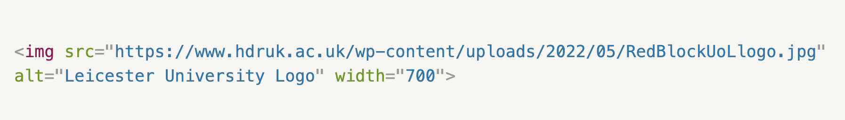

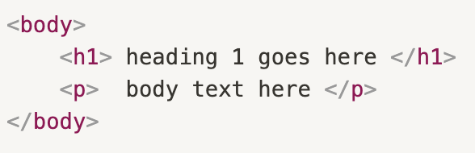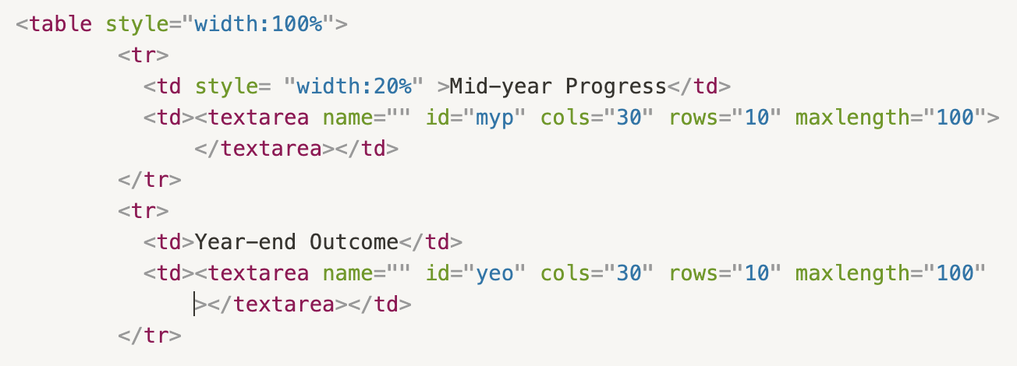

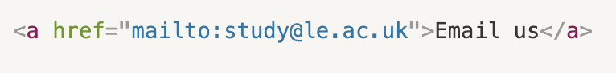

**SEMANTIC ELEMENTS**

Elements should be chosen semantically. That means in a way that most accurately describes the content's meaning. A semantically marked-up document ensures your content is available to a wide range of browsing environments and devices.

**CSS**

I used Inline style properties which is specified directly in an individual element's tag, document-level styles which is a collection of rules embedded in HTML ‹head› element and external style sheets which is a style sheet (in a separate file) is linked to the document. I used a background colour property to specify the background colour of the website. I also used text align, decoration and transformation properties. Furthermore, I modified the font size and style. Lastly, I used the box model properties including padding, border and margin to modify the website.

**JAVASCRIPT**

I made the page more interactive with dialogs. I made popups that can display text and receive input. Also, I used alert popup which displays a message that can confirm dialog by displaying a message, "OK", and "Cancel" buttons. Finally, I used a prompt dialog which is triggered using built-in JavaScript functions.

**PROJECT EVALUATION**

Overall, the project went successfully. I managed to use reach my goals. One lesson learnt is the importance of organisation when dealing with large HTML/ CSS files I have learnt. One difficulty faced was not structuring the file effectively which may lead to user errors. I dealt with this by making sure the codes were written succinctly with the useful comments to improve readability.